Press Release
For immediate release
May 23, 2019
‘A Great Big Week For Legs & Feet’ first Legs Matter Week kicks off in Dorset June 3-7
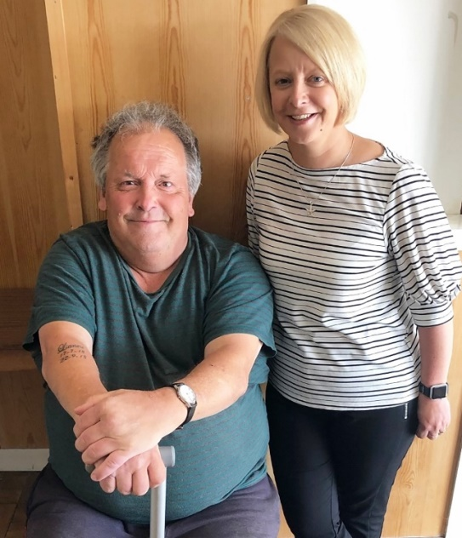
Patient Christopher Creech, from Upton, with Legs Matter coalition member and Poole nurse practitioner Clare Mechen.
Every two hours in England, someone loses their leg due to a non-healing wound - ‘A Great Big Week For Legs & Feet’, the first, national Legs Matter Awareness Week, June 3-7, is being held to urge people to ‘stand up’ to one of the UK’s biggest health challenges.
Locally, across Dorset CCG region in 2016-17, an estimated 934 people had diabetic foot ulcers costing the NHS an estimated £10.6 million and there were 313 resulting amputations.
On May 11, staff at The Best Foot Forward Leg Club and The Adam Practice, Blandford Road, Poole, ‘stood up for legs’ by walking the 21 miles from Lulworth Cove to Swanage, raising just over £2,000 for much-needed ‘Well Leg’ equipment.
Leg Club patient Christopher Creech is 67, of Upton, Dorset, has been having treatment for leg ulcers for the past nine years. His story starts with what he thought was just a simple insect bite.
“It all started when I got stung on the back of one my calves. My leg was itching like hell. I thought it’d go away on its own but when I looked at my legs, they were covered in blisters. From the knee to the ankle – just covered. I’d put plasters on my legs, but the blisters would just leak through. I’d get by with the pain. It was the smell that was the problem.”
Things began to change when Christopher found his local Leg Club: “It was at the local working men’s club. I’d go along every week and the nurses would dress my legs properly. They’d do it really tight. You could feel the difference. I’d go along the next week to get it done again and you could see that my legs were getting better.”
After regular treatment at the Leg Club, Christopher’s leg ulcers began to heal. He continues to go to the Leg Club every week to have his legs checked.
Legs Matter coalition member Clare Mechen, and the dedicated nursing team which provides clinical care to Christopher, are urging people to play their part by checking their own and others’ legs and feet for 10 possible problems, including swollen, tender legs or sores that won’t heal. They want people to get involved by holding their own ‘Legs Matter Natter’ and to take action with the ‘Legs Matter Pledge’ and by ‘Sharing Your One Big Thing’ - one important fact people wished they had known earlier about leg and foot health.
The advanced nurse practitioner at the Adam Practice and The Best Foot Forward Leg Club, said: “There are more than a million people suffering with lower leg and feet disorders - many of which are life changing. These conditions are often overlooked by patients, carers and clinicians. We are passionate about changing this.
“We want people to check their own and others’ legs and feet and to speak to a pharmacist, nurse, podiatrist or GP if they are concerned. Getting early treatment makes all the difference and prevents the condition becoming more serious.”
Each year, it is estimated that more than a million people in the UK suffer from serious leg and foot conditions and the resulting delays to correctly diagnose and treat them can cause unnecessary suffering, disability, amputation and even death.
Now a group of the UK’s leading lower limb clinicians, led by the Tissue Viability Society, have joined forces to encourage people to check their legs and feet, to get medical help fast and to highlight what level of care patients have a right to.
Costing the NHS up to £5.3 billion annually, leg and foot ulcers, oedema (a failure of the lymphatic system), narrowing of the arteries and other serious problems need to be treated quickly and correctly to reduce the risk of non-healing wounds, secondary health problems and deteriorating health. An NHS England study estimates that having effective care early, reduces leg ulcer healing times from around two years to just a few months and is 10 times cheaper. But many patients suffer unnecessarily for several years due to a lack of knowledge and not accessing the right care.
Supported by NHS England, a group of eight health care charities and not-for-profit organisations have come together to tackle the issue. As part of this, they have produced an online checklist for people, including health care professionals, to recognise the signs and symptoms of lower leg and foot problems.
Leading clinicians from The Tissue Viability Society, The British Lymphology Society, Accelerate CIC, The College of Podiatry, The Society of Vascular Nurses, The Lindsay Leg Club Foundation, Foot in Diabetes UK and The Leg Ulcer Forum have formed Legs Matter and want to ensure that anyone with a lower leg or foot problem understands their condition and gets the urgent care and support that they need.
A patient will encounter a number of people along their journey to diagnosis and treatment – from the pharmacist, to the practice and community nurse, to the GP and beyond. The Legs Matter coalition want to make sure that every person, including the patient, has the information that they need to take the best steps towards healthy, pain-free legs and feet.
You can find top tips for leg and foot health in the Legs Matter leaflet and order a free Action Pack. Let us know what you’re up to and what you’ve pledged on Twitter or Facebook using the hashtag #legsmatter, or drop us an email.
…ends…
Note to Editors:
Access reports, high resolution images of Christopher Creech and more photos here. Read his full story here
During the week, group members and their supporters are holding a series of nationwide events for both the public and health professionals, including working alongside homeless organisations in London, the first Legs Matter Conferences in Oxford and Newcastle and raising the issue with world-leading vascular experts.
And a Headline Report by Legs Matter chair Dr Leanne Atkin reveals how living with long-term leg and foot conditions can lead to loneliness and feeling isolated. Other leg and feet facts:
- Annually in the UK, 730,000 people will have a leg ulcer, 169,000 will have diabetic foot ulcers and a further 100,000 each year will suffer from lymphoedema (failure of the lymphatic system)
- In addition, narrowing of the arteries (peripheral arterial disease or PAD) affects one in five people over the age of 60 in the UK who are at risk of lower limb loss and increased risk from death from heart attack and stroke
- Each year, complications among patients with diabetes and PAD result in 5,000 – 6,000 lower limb amputations
- The cost of caring for people with diabetic foot ulcers is estimated to be £650 million, predominantly from nursing care and admissions – diverting resources from other patients and creating huge workforce pressures
- Just 47 per cent of leg ulcers healed within one year
- Chronic oedema affects more than 429,000 people in the UK and is rising year-on-year due to an aging population and growing levels of obesity
- Every hour in the UK someone over 50 has part of their foot amputated
- Amputations are 70% higher in the UK’s Black population
- There is a North/South divide with major amputation rates 30% higher in Northern England compared with the South.

Media contact: For more information or to request an interview, please contact Cathy Kelly on 07704 130226 or email cathy@catherinekellypr.co.uk

